Dongguan"Songshan Lake Cup" Innovation and Entrepreneurship Competition (European division) starts registration
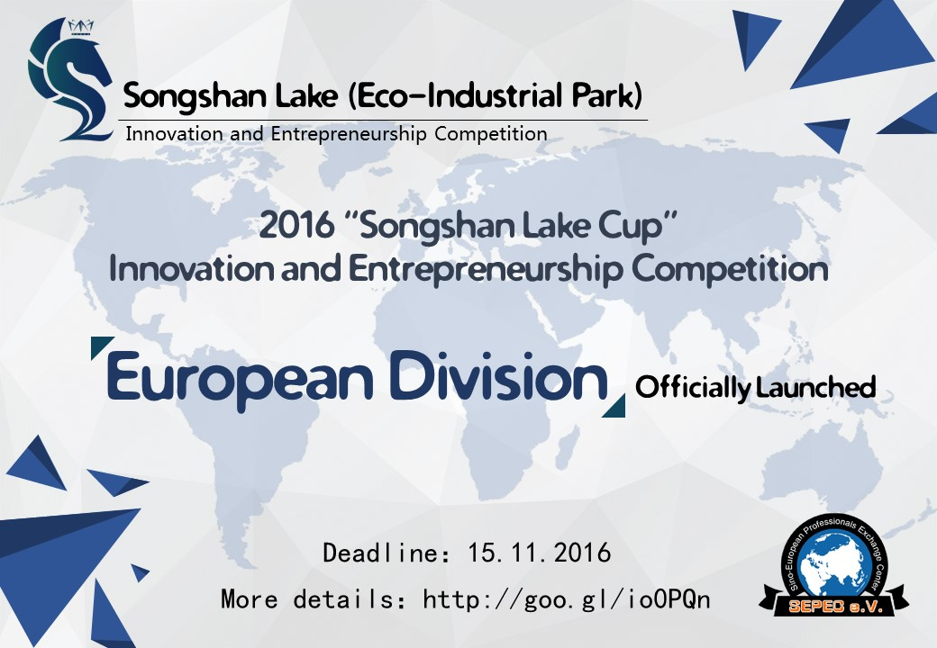

Introduction

Background
Involving in the new normal economic growth, Dongguan as a veteran manufacturing-featured city is willing to promote economic restructuring and industrial transformation and upgrading during the 13th Five-Year Plan period of Chinese government, then ultimately realize the "machine substitutions", "two fusion", "Dongguan Manufacturing 2025 "and other strategic objectives. In order to achieve the above goals, Dongguan needs to intensify efforts to build high-end talent highland, innovative enterprise and regional innovation heights.

To fully implement the innovation-driven development strategy, build the atmosphere and platform for the mass entrepreneurship and innovation, accelerate the construction of the Songshan Lake Park technology innovation service echelon, reserve long-term development momentum of the park, explore and attract innovation and entrepreneurship talents, straighten out and perfect science and technology service system and realize the dream of innovation and entrepreneurship, Songshan Lake (Eco-Park) National New & Hi-Tech Industrial Development Zone (i.e. Songshan Lake Park) decides to hold the "Songshan Lake Cup" Innovation and Entrepreneurship Competition. This Competition takes the "innovation-driven, Songshan Lake dreams" as the main thrust and support the development of those projects which are of products promotion needs, government support and venture capital needs in Dongguan. The competition officially started in October, 2016 and the finals of Europe division, Silicon Valley division, Taiwan division and Songshan Lake division will be held in December, 2016.
In line with the principle of fairness and openness, the business plan and the performance on the pitch presentations of divisions will be appraised by experts. Through the above selection, all chosen outstanding projects teams will get together in Songshan Lake, Dongguan in January 2017 to fight for the rewards which is 4.3 million RMB yuan and 20 places in total.
Besides, every project team interested in landing after the competition will be aided by Songshan Lake Park to get the capital docking, entrepreneurial space and park policy support and park business services.
After landing the project, if the project gets further reward from the national, provincial and municipal talents policies, Songshan Lake Park will offer the same amount of funding because of implementation of the project in Songshan Lake Park.

Global finals （January 2017, Songshan Lake Park, Dongguan）
- The competition will be divided into two groups (startup group and enterprise group) regardless of industry fields, while the oversea divisions will be grouped according to the registration status of enterprises.
- According to the number of enterprises being recommended to enter the global finals, the finals will be divided into semi-finals and the finals. About the people who are invited to participate the semi-finals and finals, for enterprise group, the CEO, CFO and CTO of the company should attend the finals, and for startup group, the core members of startup team (no more than 3 people) should attend the finals. Organizing Committee of the competition will reimburse certain amount of the cost of food, accommodation and journey to the teams.
- In the semi-finals, each team will have 10 minutes for roadshow and 6 minutes for defense. At the end, 10 outstanding projects will be chosen from each group to participate in the finals.
- The finals will be live broadcast by China IT media. The finals will include project video display (optional), project roadshow and expert quiz. At the end, there will be for each group one first prize, two second prize, three third prize and four winning prizes to share 4.3 million RMB yuan rewards.

European division（December 2016, Munich Germany）
- European division will not group all projects into startup group and enterprise group.
- European division will be co-sponsored by Sino-European Professionals Exchange Center-SEPEC e.V. and German Incubator, in collaboration with the Chinese-German Innovation and Entrepreneurship Association, German local venture capital funds and the experts from whole Europe, to build Dongguan’s international business card.
- The review board of European division compose of well-known Chinese investors, entrepreneurial mentor from UnternehmerTUM, Professors, German local venture capitalists. The review board will review all registered projects and recommend 14 projects to the European division.
- The 14 teams being recommend by the review board will participate in the finals of European division in Munich, the cost of journey and accommodation for attending this finals will be reimbursed by the organizing committee of European division.
- The official language of European division is English, which mainly includes 8 minutes roadshow in English and 7 minutes defense in English. The review board will score all projects based on the roadshows and business plans and then rank the first, second and third prize to 10 winning teams.
- These 10 teams will be recommended to participate in the global finals in Songshan Lake Park, Dongguan. The organizing committee of global finals will reimburse certain amount of the cost of travel and accommodation.
- Media support: Kaiyuan network and German channel of the People's Daily Overseas Edition.

Participation Information

Focused industry sectors
It is necessary to meet the "4 + 1" industrial categories, namely electronic information industry, biotechnology industry, robot industry, new energy industry, modern service industry (cultural innovation and E-commerce) and other strategic emerging industries. Projects which have won the 2015 Songshan Lake Cup prize are not qualified to join in the competition this year.

Participation requirements
Startup Group
- Participants should have innovation- and entrepreneurship-related oversea experience, and master the industry's cutting-edge technology, technical achievements or management experience. Meanwhile participants should be interested in starting up business or working in Dongguan.
- Before the registration to this competition, participants have not registered or set up a business or worked in China. And the members of each team should not be less than 3.
- Participants have to agree to register an enterprises or work in Dongguan within 3 months after the global finals.
- Participants’ integrity about the innovation experience is assumed. At the same time, the participants need to have the property rights to the innovations and have no property disputes. Participants are responsible for outcomes of the infringement and dishonesty during the competition.
- Participants have to agree to be checked about the information related to the projects from the review board of this competition.

Enterprise group
- Participants are preferred to be small and medium-sized innovative enterprises in the world and have independent intellectual property rights;
- Participants are preferred to be technology-based small and medium-sized enterprises that have a sales volume no more than 150 million yuan in 2015;
- It is necessary to meet the "4 + 1" industrial categories from Songshan Lake Park, have independent intellectual property rights and no property disputes;
- Participants should be unlisted enterprises and have no bad legal record.
- Participants have to agree to be checked about the information related to the projects from the review board of this competition.
- Participants have to agree to register an enterprises or work in Dongguan within 3 months after the global finals.

Application
- Participants will not be grouped in European division and the same rules will be applied to every project. Meanwhile, participants have to register with email accounts.
- All enterprises and teams participating in the domestic Songshan Lake Park division (in China) have to register through the homepage of this competition (http://cxcyds.ssl.gov.cn)

Application access (deadline: November 20, 2016)
Chinease Students and Scholar Association at Helmholtz Munich Center received the commission from Sino-European Professionals Exchange Center-SEPEC e.V., the organizer of European division that through the following registration email address to accept all applications:
Helmholtz.munich+songshanlake@gmail.com
- Application Form -2016 "Songshan Lake Cup" - European division.doc (compulsory)
- Business plan template – 2016 "Songshan Lake Cup". Doc (the template is for reference only, under the premise of all required information being included, a prepared business plan is acceptable.) (compulsory)
- Photo of the team.pdf (compulsory)
- Product Image.pdf (compulsory)
- Patent Certificate.Pdf
- Novelty assessment report.pdf
- Test Report.pdf
- Other certificates demonstrating the competitive advantage of the project or team.pdf
- Business license or company registration file.pdf (for registered enterprises, to participate in business group finals, this is compulsory. Optional for startup teams.)
- Financial Statements .pdf (for registered enterprises, to participate in business group finals, this is compulsory. Optional for startup teams.)

Assessment criteria
The review board of European division composes of experienced venture capitalists, well-known entrepreneurs and experts from technical fields. In the principle of openness, fairness and justice, the project will be graded according to the following evaluation standards:
 | Evaluation items | 100
1 | Product / service novelty (unique selling point / value, patented technology, etc.) | 15
2 | Target customers and success cases (customer groups, whether there are angel customers, the typical customer development status, etc.) | 10
3 | Target market conditions (capacity, occupancy, growth, competitive landscape, etc.) | 10
3 | Business model (CRM, distribution channels, supply chain, R & D production strategy, key resources, key partners, etc.) | 15
4 | Team evaluation (members, industry experience, implementation capacity, management, division of labor, etc.) | 15
5 | roadshow performance (novelty of presentation, clarity of presentation, be expressive, etc.) | 10
6 | Risk control and prevention (production, marketing, management, team, technology, policy, law, etc.) | 10
7 | Enterprise development plan (long-term vision, major milestones, importance of current project, achieved goals and next steps, etc) | 10
8 | Financial forecast (the next three years) and financing options (capital requirements, fund utilizing plan, equity transfer ratio, etc.) | 5
*The above criteria are for the European division only. The global finals are divided into Enterprise group and Startup group, so the standard will be slightly different.

Rewards
Level | Awards | Quantity | Startup group | Enterprise group | Remarks
Global finals | First prize | 1 | 0.35Million yuan | 0.55Million yuan | projects and companies need to finish the industrial and commercial registration and land in the park and submit the relevant documents to the Organizing Committee to apply for prize money within 3 months after the competition.
 | Second prize | 2 | 0.25 Million yuan | 0.35 Million yuan
 | Third prize | 3 | 0.15 Million yuan | 0.25 Million yuan
 | Winning prize | 4 | 0.1Million yuan | 0.15 Million yuan
European division | First prize | 1 | 1500 euros |  | No need to settle in Songshan Lake Park  Awards will be available in finals in Dongguan.
 | Second prize | 3 | 800 euros
 | Third prize | 6 | 500 euros

Support policy
Besides the support from the framework of ‘Science and technology policy’and ‘Key industrial policy’ of Dongguan, Songshan Lake Park and Dongguan City also provide talents and their families with life, work, education and medical care supports. By providing a rich, multi-level support for the talents in startup and business, Songshan Lake Park promise to help the talents work and live happily in Dongguan.
To provide a window for oversea talents to better understand Dongguan and Songshan Lake, Dongguan Municipal Government will hold ‘Talents week’whose theme is "Innovation-driven development, Talents-driving Dongguan" from23th, November to 25th November 2016.

Talent Policy
According to various existing codes and government supporting frameworks and the upcoming multiple level support policies for talents, Dongguan Songshan Lake Park will provide up to 1: 2 monetary grants for both talents and projects for the winner of varied entitlements, covering international, national, provincial and municipal level talents title).

Venture Capital and Preferential Policies
Professionals supported by ‘Dongguan leadership of entrepreneur’program will get 2 million yuan as startup grant in the first 2 years. After the first 2 years and the adoption of experts, talents can receive another 3 million yuan as awards.
Project teams got supported by‘Dongguan scientific research teams’program, can receive 5 to 10 million yuan funding after the initialization of projects. Upon the finalization of the project, teams will receive the awards no more than the funding given for project initialization according to the implementation condition and degree of contribution of the project.

Venture Capital and Incubation
The Organizing Committee together with all organizers and co-organizers will give full play to possessed advantageous resources, initiate matching meetings for venture capital institutions, well-known enterprises, project teams and individuals to strengthen the exchange between overseas talents and local capitals. Other efforts will be made to promote the soft landing, implementation and transformation of projects in the Songshan Lake park.
Scope | Content | Remarks
Capital docking | Organize business matching meetings for the PE, VC and outstanding projects. Provide inquiries, match-making meetings, projects roadshow, closed-door meetings and other services for the participants and investors in cooperation. | 1. Including but not limited to winning projects
Entrepreneurial space | The winning teams will be granted the Songshan Lake office area and services support from the park, such as housing subsidies (no bigger than 60 square meter within 2 years and the subsidies per square meter is no more than 30 yuan and so on). | 1. The project is a startup project for international graduate students and available to settle in Songshan Lake park.  2. The winner of all divisions;
Startup project | For the enterprises and teams settled in the park, relevant functional departments of the park will provide entrepreneurship training, application training for funds and talents title, management consulting, mentoring, patent applications, resource sharing, exhibition, international exchange and talent recruitment and other services. | 1. Project settled in Songshan Lake;  2. Projects participating the competition will be prioritized.
Tracking service | After settling in Songshan Lake Park, the winning projects will enjoy relevant service based on the phase of the project, including:  One contact will be assigned to each team for project progress update and communication;  One team will be aided by a business mentor;  Talents recruitment and entrepreneurship Salon will be held for enterprises;  Discount for local purchase will be given;  The platform to promote the sales of innovative business and other activities will be built;  Organize specialized institutions to help start-up enterprises to apply for national, provincial funds, “the Thousand Talents Plan” and other talents policies (Such as incubators, the administration offices in the Park, specific contact person);  After settling, free services, such as paperwork polishment will be available.  For academic talents, help to build more communication and cooperation channels to universities and institutes to promote the transformation of research results to production, meanwhile providing the soil for the talents to root in Dongguan. | 1. Project settled in Songshan Lake;  2. Projects participating the competition are prioritized.
Loan discount | No more than 70% bank loans discount within two years, each enterprise loan up to 1 million. | 1. Projects settled in Songshan Lake and experts titled by Dongguan.

Other supports
Dongguan will support the talents setting up business or work in Dongguan from all aspects of life and work, including (but not limited to): talents can enjoy the simplified registration of business with priority, apply for housing subsidies; be available to medical treatment through VIP channel (in second-class or better hospitals), annual physical exam and personalized health care programs; get 80% refund from personal income tax (the part retained by local government) and choose one of the municipal level or better public primary and secondary schools for children's compulsory education.

Contact us
Manager：Yuanhui Huang
Vice President, Sino-European Professionals Exchange Center-SEPEC e.V.
Telephone：+4917681700478/
Wechat: HuangYH2012
Email：yuanhui.huang@tum.de

Sino-European Professionals Exchange Center-SEPEC e.V.

